**Tableau – Driven Smartphone Insights : A Comprehensive Analysis**

**Problem Statement:**

In an increasingly competitive market, ABC Company faces the challenge of maintaining its position as a leading provider of smartphones. With consumer preferences evolving rapidly, there is a pressing need to understand the dynamic landscape of smartphone features, including prices, ratings, and processor performance. ABC Company must navigate this complex environment to identify key market trends, consumer demands, and areas of opportunity. Additionally, ensuring alignment between product offerings and consumer expectations is paramount for sustaining market relevance and driving growth. To address these challenges effectively, ABC Company requires a strategic approach that leverages data-driven insights to inform product development, marketing strategies, and business decisions, ultimately positioning the company for continued success in the ever-changing smartphone market.

**Prerequisites:**

* Basic understanding of Data Analytics

[What Is Data Analytics? - An Introduction (Full Guide)](https://youtu.be/yZvFH7B6gKI?si=jD37tQzKJH1vl56A)

* Awareness of the lifecycle of a Data Analytics Project

[A Beginners Guide To The Data Analysis Process](https://youtu.be/lgCNTuLBMK4?si=a_J79oNSQIGNuNlH)

* Understand Tableau Interface- [Link](https://www.youtube.com/watch?v=oIw8xJ1Fy3w)
* Download Tableau Desktop-[Link](https://www.tableau.com/products/desktop/download)

**Objective:**

An objective is a specific, measurable, and time-bound goal or target that an individual or organization aims to achieve. Objectives are typically set to guide actions and decision-making towards desired outcomes. They are often a part of broader goals and help to clarify what needs to be accomplished within a certain timeframe. Objectives should be realistic, achievable, and relevant to the overall mission or purpose, providing a clear direction for efforts and resources.

**Task:**

* Utilize visualizations to analyse the count of smartphones, total prices, and ratings to gain insights into market trends and consumer preferences.
* Investigate the distribution of prices by model and ratings by Processor to identify patterns and opportunities for product optimization and market positioning.

**Dataset**: [Link](https://www.kaggle.com/datasets/shrutiambekar/smartphone-specifications-and-prices-in-india)

**Solution Development Procedure:**

* In Tableau, the "Connect" option refers to the initial step in the data visualization process where users connect to various data sources to import data into Tableau for analysis and visualization.

* When you select the "Connect" option in Tableau, you are presented with a variety of data connection options.

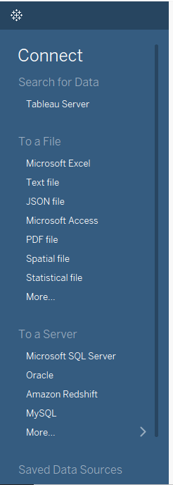

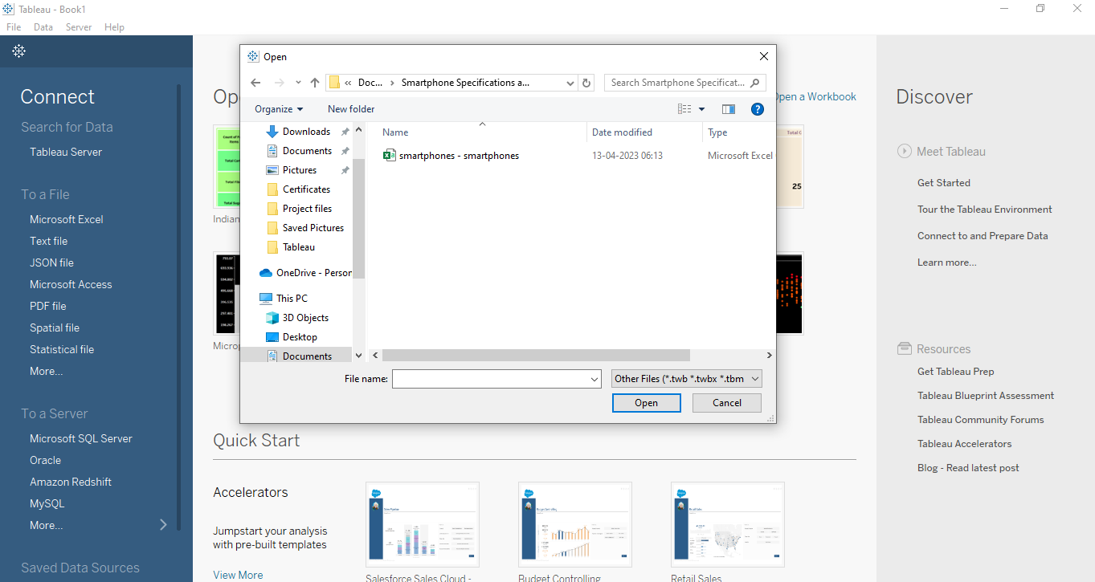

* Once we load the data into the Tableau.

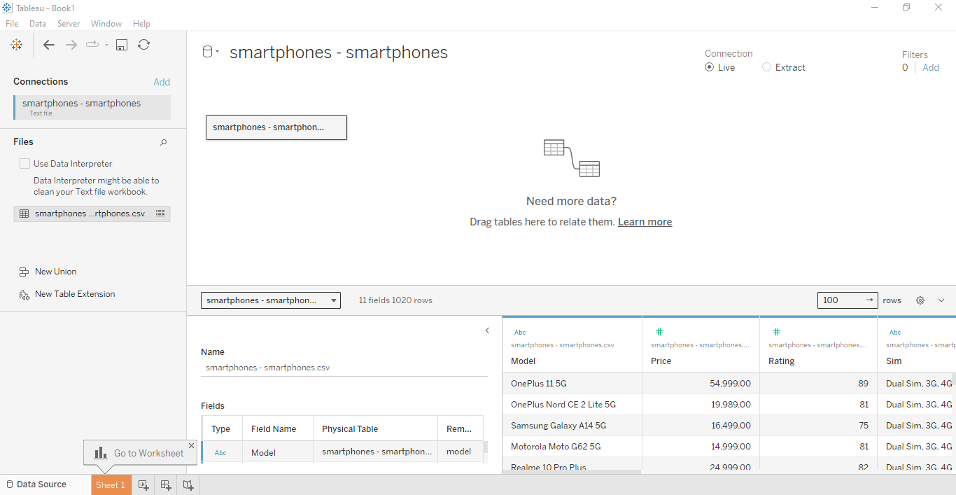

* Now , we proceed to create dashboard for Smartphones Insights Hub.
* To create the dashboard, which will satisfy the task above, we consider the followingcolumns:
  + Count of Smartphones
  + Total Prices of Smartphones
  + Total Rating of Smartphones
  + Total Prices by Model
  + Total Rating by Processors
* We have created the dashboard which is presented below.

**Dashboard:**

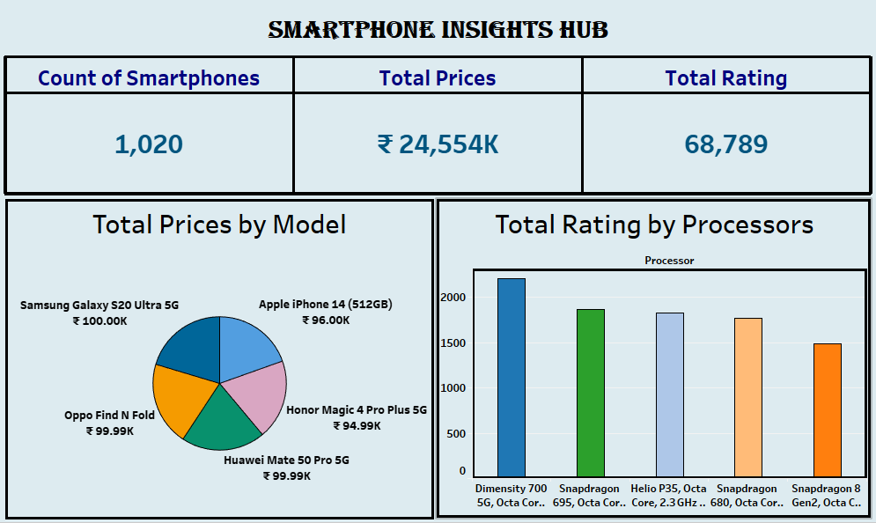

**Explanation Video:** Link

Note: The explanation video for the dashboard is in the link above.

**Insights:**

Insights refer to valuable and meaningful understandings or perceptions gained from analysing data, information, or experiences. They provide deeper understanding, clarity, or revelation regarding a particular subject or situation.

* The dashboard reveals a diverse range of smartphones, with a total count of 1,020, reflecting a rich variety of options available in the market.
* Analysis of total prices showcases the significant investment consumers make in smartphones, totalling ₹24,554K. Notable high-end models such as the Samsung Galaxy S20 Ultra 5G and Apple iPhone 14 (512GB) command premium prices, highlighting the demand for flagship devices.
* The distribution of ratings by processors offers valuable insights into consumer satisfaction. Smartphones featuring the Dimensity 700 processor tend to have moderate ratings, while those powered by Snapdragon processors, such as Snapdragon 695 Octa Core, receive higher ratings, indicating their popularity and perceived performance among users.

**Conclusions :**

Conclusions are logical deductions or decisions drawn from observations, evidence, or analysis. Conclusions are often based on the findings or results of a study, experiment, or evaluation, and they aim to summarize key insights or outcomes. Effective conclusions should be supported by evidence, logical reasoning, and critical thinking, leading to well-informed decisions or actions.

* The visualized data illuminates key trends in the smartphone market, offering insights into the distribution of smartphones, total prices, and ratings, which are crucial for understanding consumer preferences and market dynamics.
* Analysis of prices by model and ratings by Processor uncovers patterns that can inform strategic decisions related to product development, pricing strategies, and targeted marketing efforts.
* Leveraging these insights, stakeholders can make informed decisions to optimize product offerings, improve customer satisfaction, and stay competitive in the rapidly evolving smartphone market.